CHIP 690 mProject 4 Yannick Apedo

RE: Real Estate Conference

Hey Pat!

I was able to review the data and found some important results relating to your question on home size and neighborhood quality. Please review the attached Word document to see what I was able to interpret.

Best,

Yannick A.

Overall, the most important thing to know is that when we use regression analysis, or the study of strength between two variables, particularly in healthcare and behavioral science research, the relationship between our independent and dependent variables can depend on a 3rd or moderator variable. In this case, our IV would be home size, moderator variable would be neighborhood quality, and price would be the DV. As you can see below with the “Model Summary”, the main effects for each variable, size and quality, on price. With R-squared values above .9, we can see that there highly significant main effects for size and quality and a significant interaction. I also included parameter estimates.

|  |  |  |  |  |  |
| --- | --- | --- | --- | --- | --- |
| **Descriptive Statistics** | | | | | |
|  | N | Minimum | Maximum | Mean | Std. Deviation |
| Community quality | 36 | 1.00 | 5.00 | 3.0000 | 1.65616 |
| Size (in square feet) | 36 | 1100.00 | 3000.00 | 2075.0000 | 608.68711 |
| Valid N (listwise) | 36 |  |  |  |  |

|  |  |  |  |  |  |  |  |  |  |
| --- | --- | --- | --- | --- | --- | --- | --- | --- | --- |
| **Model Summary** | | | | | | | | | |
| Model | R | R Square | Adjusted R Square | Std. Error of the Estimate | Change Statistics | | | | |
| R Square Change | F Change | df1 | df2 | Sig. F Change |
| 1 | .985a | .971 | .969 | 10906.06050 | .971 | 554.285 | 2 | 33 | <.001 |
| 2 | .996b | .992 | .991 | 5982.56815 | .020 | 77.667 | 1 | 32 | <.001 |
| a. Predictors: (Constant), Quality_c, Size_c | | | | | | | | | |
| b. Predictors: (Constant), Quality_c, Size_c, Int_SizeXQuality | | | | | | | | | |

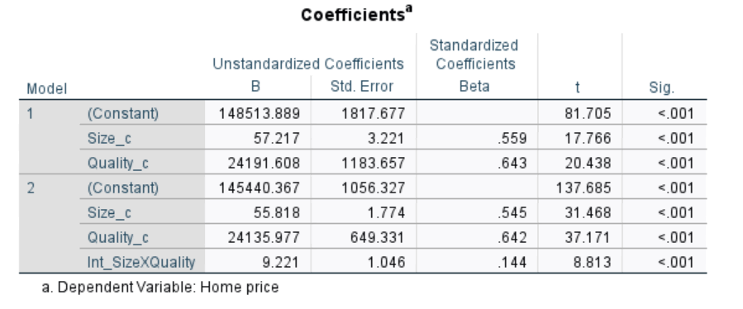

Next, I used a formatted simple slopes model on Excel to find interactions between size and quality. Overall, these results show that the 3 main slopes (based on neighborhood quality) are significantly different from 0.

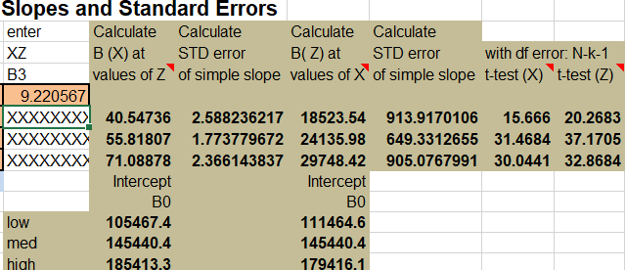

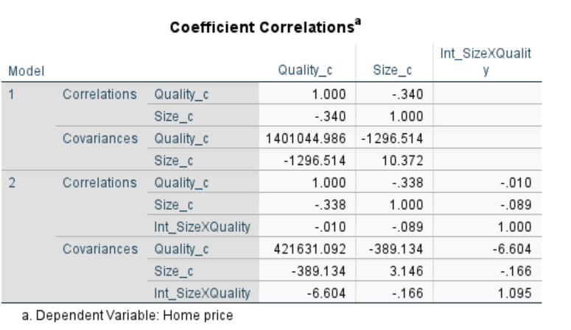

Below I included two graphs: the first graph depicting the differences in home sizes across the X-axis (while dividing by neighborhood quality), while the second graph covers a broader spectrum of neighborhood qualities (X-axis values represent the minimum and maximum values for X1).

As we can see from the graphs, the lines represent the quality of neighborhoods. Overall, we see that as house size increases, the price also increases, which is observed across all forms of neighborhood quality. It is important to note that this is more evident in higher quality neighborhoods, as there are steeper slope/increases for higher quality neighborhoods.